Introduction to CAD

Computer-Aided Design (CAD) has revolutionised the interior design industry by offering designers powerful tools to visualise, draft, and present their ideas with precision and efficiency. From simple floor plans to immersive 3D renderings, CAD enhances every stage of the design process. This article explores what CAD is, how it's used in interior design, the range of hardware and software involved, how it integrates with other tools, and its pros and cons.

# What is CAD and how is it used in Interior Design?

CAD stands for Computer-Aided Design. It refers to the use of computer systems that aid the creation, modification, analysis, or optimisation of a design. Originally developed for engineering and architecture, CAD is now a cornerstone of modern Interior Design, enabling professionals to produce detailed drawings and lifelike renderings.

Interior designers use CAD for a variety of tasks, including:

Space planning: Creating accurate floor plans and layouts to scale.

3D visualisation: Generating realistic renderings of interior spaces to help clients visualise the finished result.

Furniture and fixture placement: Ensuring proper fit and flow within a room.

Material and lighting simulation: Testing different textures, colours, and lighting setups virtually.

Construction documentation: Producing technical drawings needed for permits and contractor instructions.

CAD not only improves accuracy but also streamlines collaboration between designers, clients, and contractors.

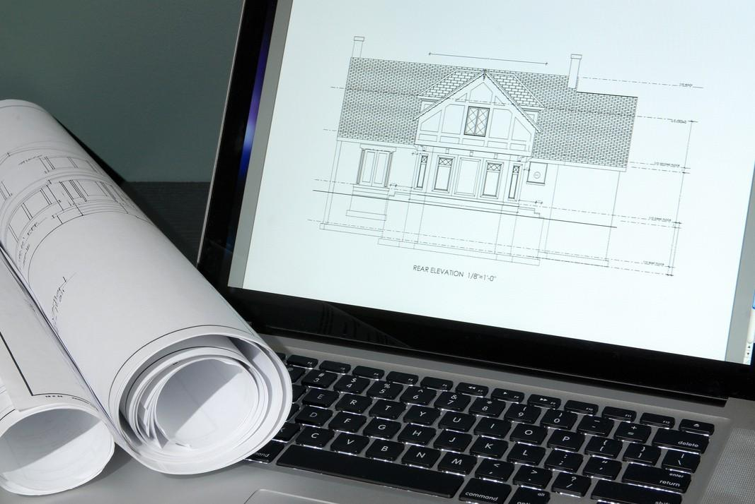

Fig 1. Canva (nd), [CAD Drawings](https://www.canva.com/photos/MAEEvBTj_w4/)

**CAD Hardware and Software**

## Hardware

To run CAD applications smoothly, interior designers often rely on certain hardware. These will change dependent on the evolution of tehcnology and the requirements of each Designer indivisually:

High-Performance Computer: A computer with a fast processor and a solid-state drive (SSD) for quick file access.

Dedicated Graphics Card (GPU): Essential for rendering 3D models and visuals smoothly. Large Monitors or Dual Displays: Allow for viewing drawings and tool palettes simultaneously, improving workflow and comfort.

Digital Drawing Tablets: Brands like Wacom offer tablets that enable freehand sketching directly into CAD programs.

3D Scanners: Useful for capturing existing room dimensions and translating them into digital models.

VR Headsets (optional): Used in advanced setups to give clients immersive experiences of their designed spaces.

## Software

There is a wide range of CAD software options tailored to Interior Design needs. Depending on your required outcome, the budget you have for licensing and the amount of experience, here are some popular options in the Industry:

AutoCAD: One of the most widely used tools for 2D drafting and basic 3D modelling. Known for precision and compatibility across industries.

SketchUp: Highly intuitive and excellent for quick 3D modelling, concept development, and visualisation.

Revit: A BIM (Building Information Modelling) tool that is ideal for large-scale or collaborative projects, integrating architectural and structural data.

Chief Architect: Speciallised for interior design and home remodelling, with strong 3D rendering capabilities.

3ds Max & V-Ray: High-end tools used for producing photorealistic renderings and animations.

Rhino: A powerful modelling tool for designers interested in creating complex forms, furniture, and bespoke elements.

Fusion 360: Occasionally used for industrial-style modeling, especially in furniture design.

# Integration with other software and tools

CAD software is rarely used in isolation. Interior designers frequently integrate it with other digital tools to streamline their workflow and improve the client experience.

Common Integrations:

**Rendering Engines:** Tools like Lumion, Enscape, and Twinmotion work alongside CAD models to generate lifelike visuals, adding effects like lighting, people, and materials.

**Adobe Creative Suite:** Programs like Photoshop and Illustrator are used to create presentation boards, edit visuals, and design branding or signage elements.

**Project Management Software:** Tools like Trello, Asana, or Monday.com help track design phases, approvals, and team collaboration.

**Augmented/Virtual Reality Platforms:** Enhance presentations by letting clients experience spaces in real-time with mobile devices or VR headsets.

**Cloud Storage and Sharing:** Platforms like Google Drive, Dropbox, or BIM 360 enable real- time collaboration and file sharing with clients, architects, and contractors.

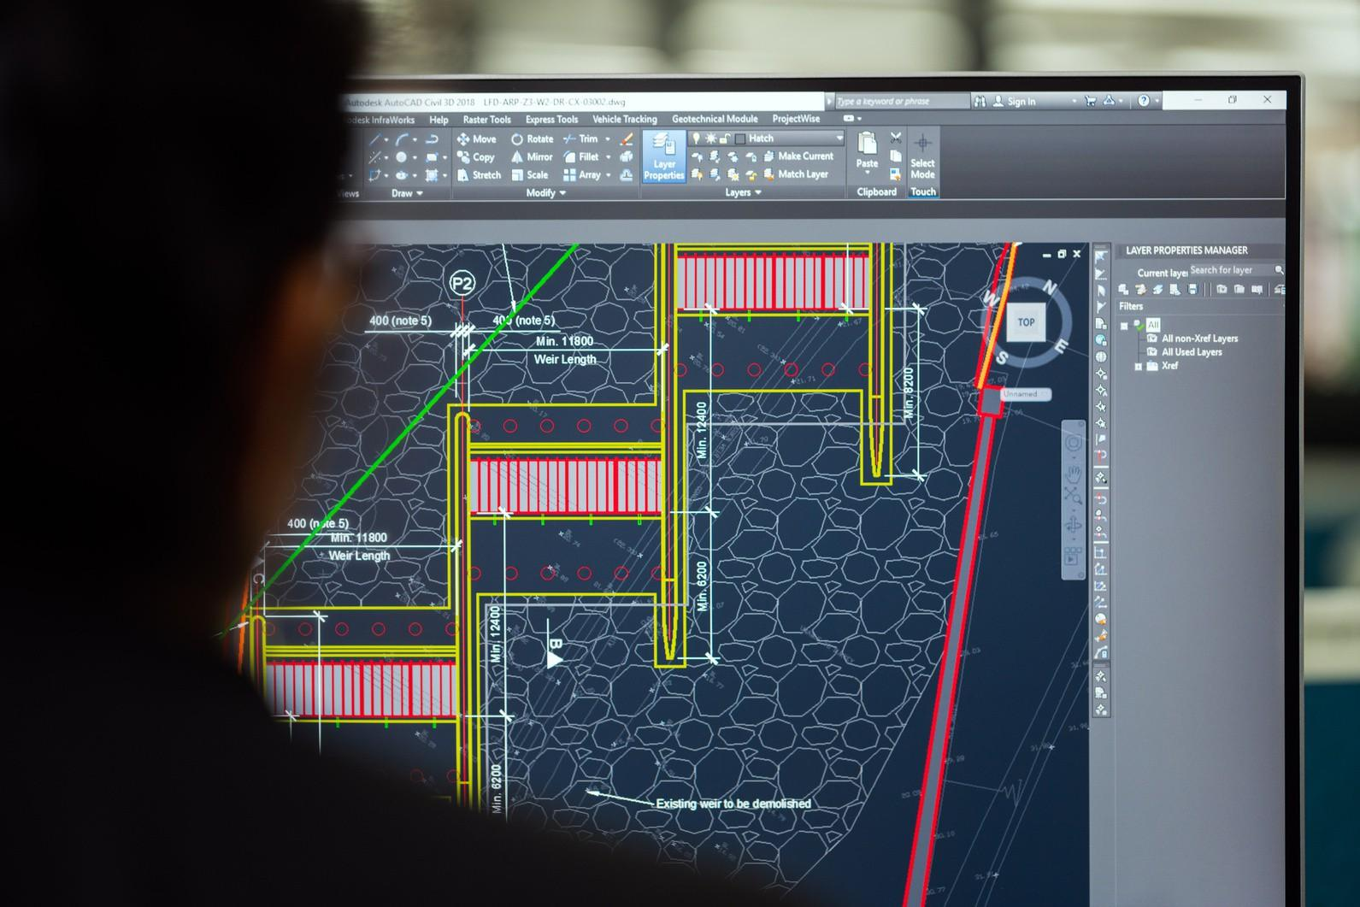

Fig 2. Pexels (nd), [Interior Designer using CAD](https://www.canva.com/photos/MAD3iupy748/)

# Pros and Cons of working with CAD

## Pros

Accuracy and Precision: Every measurement and detail can be controlled, minimising mistakes.

Design Flexibility: Easily make changes, test options, and save multiple design versions. Time Efficiency: Faster than hand-drawing, especially when creating detailed documentation. Professionalism: Produces high-quality visuals that impress clients and communicate ideas clearly.

Enhanced Collaboration: Digital files can be easily shared and integrated with other professionals’ work (e.g., architects, engineers).

**Cons**

Learning Curve: Some CAD programs are complex and require training or practice to master. Cost: Licenses for software like AutoCAD or Revit can be expensive; high-performance hardware adds to the investment.

Creativity Constraints: Over-reliance on digital tools may limit freehand creativity or organic experimentation.

Technical Issues: Software crashes, file corruption, or hardware failures can disrupt workflow. Time-Intensive Rendering: Photorealistic renderings can be time-consuming to produce without powerful hardware.



Fig 4. Presenting floor plans on a tablet

CAD is an essential skill and tool for any modern interior designer. It empowers professionals to translate ideas into reality with greater accuracy, creativity, and professionalism. By understanding the right combination of software, hardware, and integration tools, designers can optimize their workflow and deliver outstanding results. Despite some challenges in cost and complexity, the benefits of using CAD in interior design far outweigh the drawbacks, making it a critical component of contemporary design education and practice.